Millner Primary School
Sabine Road MILLNER NT 0810
“Achieving Together and Building Respect”

Principal’s Report for School Council – April, 2016

Term two has commenced and it is nice to be back into our normal school routines – whatever ‘normal’ is! The swimming program dominated the last two weeks of term one and – whilst a vital and valued learning experience for our students – it does inevitably take a little time and focus away from our day-to-day teaching and learning programs.
On swimming, apart from some minor tinkering with support staff timetables to ensure that we had adequate supervision on bus runs, the logistics of the program ran quite smoothly, with students and teachers alike enjoying themselves!

This term, we are looking to ‘reinvigorate’ the school’s Wellbeing Team, due to the departure of staff members over the past six months or so who were involved in the Wellbeing Team previously. Wendy Boehme, Sheree Arratta and myself will lead this team, which will also incorporate the ongoing implementation of KidsMatter and the leading of whole-school initiatives regarding student behaviour.

We have begun taking some small steps with our Improvement Priority of improving the integration of technology, with a couple of Professional Learning activities for teachers happening recently, as well as plans in place for Giulia Elliott-Hall to lead some regular sharing sessions at staff meetings, as well as undertake some coaching of other teachers in this area of integrating technology into teaching and learning.

Sheree Arratta and I are organising a visit to the Elite Sports Program at Casuarina Senior College, with a view to looking at ways that our students who are talented with sport can access some enhanced opportunities in this area.

We have made a slight change to the way that our Visible Learning ‘Guiding Coalition’ works, taking these meetings out of the leadership team meetings and instead having a standalone weekly time for Korin, Giulia and Warwick to meet and progress priority VL work.
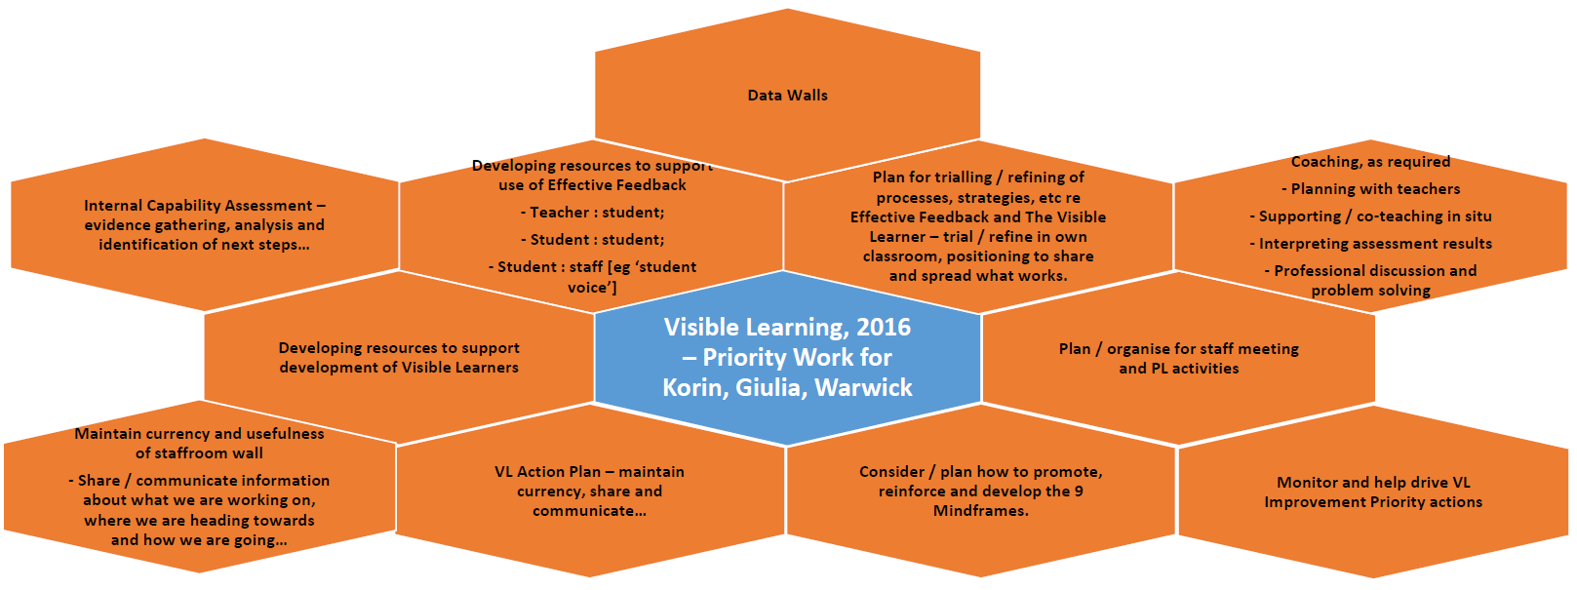

One of our Key Actions for growing enrolments is to develop the entrance area of the T/1 classrooms into a more welcoming and attractive space, leveraging the significant increase in parent traffic that we are getting in that area in 2016. Work has commenced on this, with painting happening recently and several other elements planned, following planning meetings between Giulia, Korin, Warwick and Megan, as well as input from parents.

We have had some recent staffing changes…
- Elspeth Hurse finished at Millner last Friday, moving to a job at Student Services. This move enabled us to advertise a Senior Teacher [ST1] position, which will have a strong focus on Special Education. This position was won by Sheree Arratta and Karen Piening – they will share the Senior Teacher position and continue with their team teaching arrangement with the 5/6 classes. To better enable progress with their respective Senior Teacher responsibilities, a third teacher has been added to the 5/6 ‘mix’ – Kate Murray. The addition of two new people to our leadership team has presented an exciting opportunity to relook at the structure of the leadership team and where people’s roles should be focused.
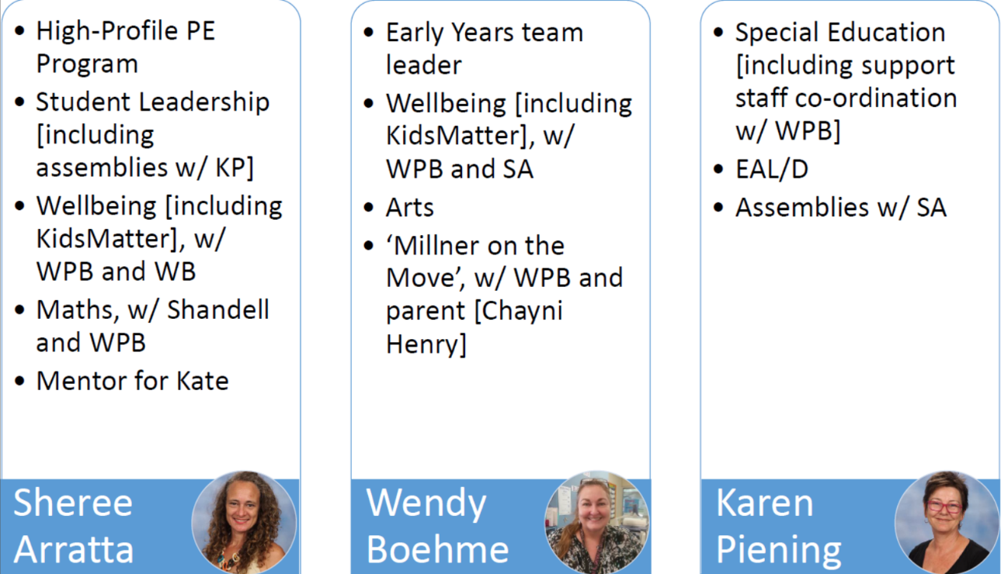

- Jill Malseed also finished up last Friday, with Belinda Esguerra coming on board to lead the Playgroup. Belinda is a very involved and supportive parent at the school, with daughters in both Transition and Preschool. She already has many plans and ideas about how to keep moving Playgroup forward!

Thank-you for your support of the school through your participation as School Council members.

Regards,

Warwick Peter-Budge

