Millner Primary School
Sabine Road MILLNER NT 0810
“Achieving Together and Building Respect”

Principal’s Report for School Council – August, 2016

Welcome back for term three and a busy start it has been, as always!

Whilst teachers were busy preparing their classrooms and programs in the days and weeks leading up to the beginning of this term, our first official day back as a whole staff was Monday, July 25, one day prior to the students commencing. This was a full but valuable day, with the majority of the day focusing upon Visible Learning – one of our ‘Big Five’ priorities in 2016 and the one with the most direct impact upon teacher practice and student learning.
The first part of the day saw us reflect upon some recent evidence gathering that we’d been doing, in order to monitor how well we were going in each of the four key strands of VL. The graph below was from a survey of staff about various feedback practices through the school and compares current staff perception about these practices with the results from 12 months ago.
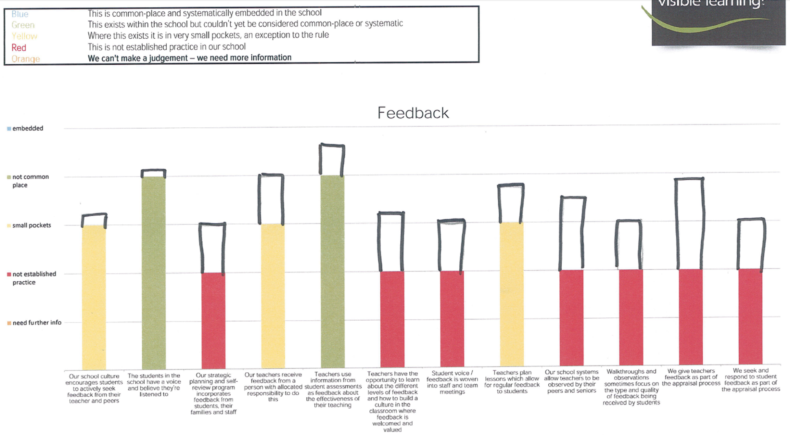

Whilst ‘Effective Feedback’ was our initial VL focus in 2015, this year we have moved onto focusing upon ‘The Visible Learner’. The following graphs represent student responses to key questions that relate to this strand.
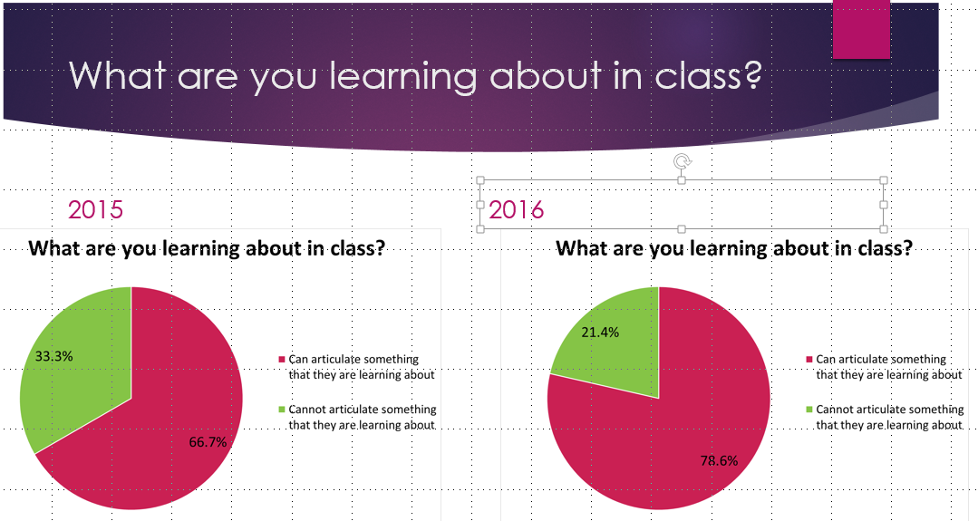
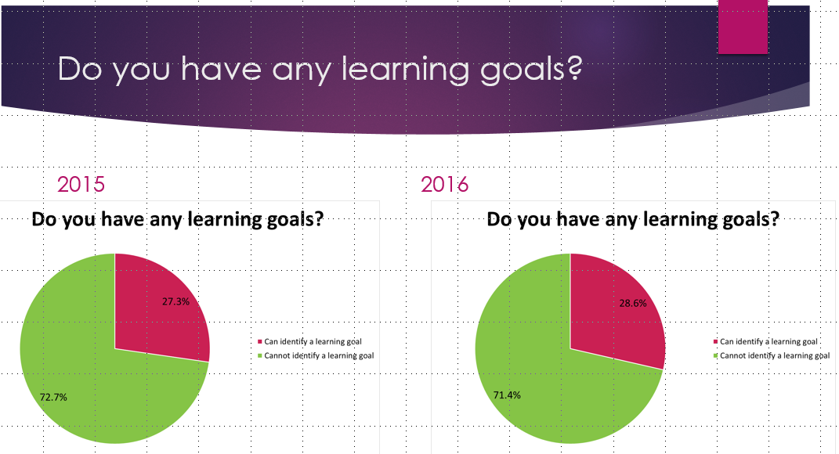
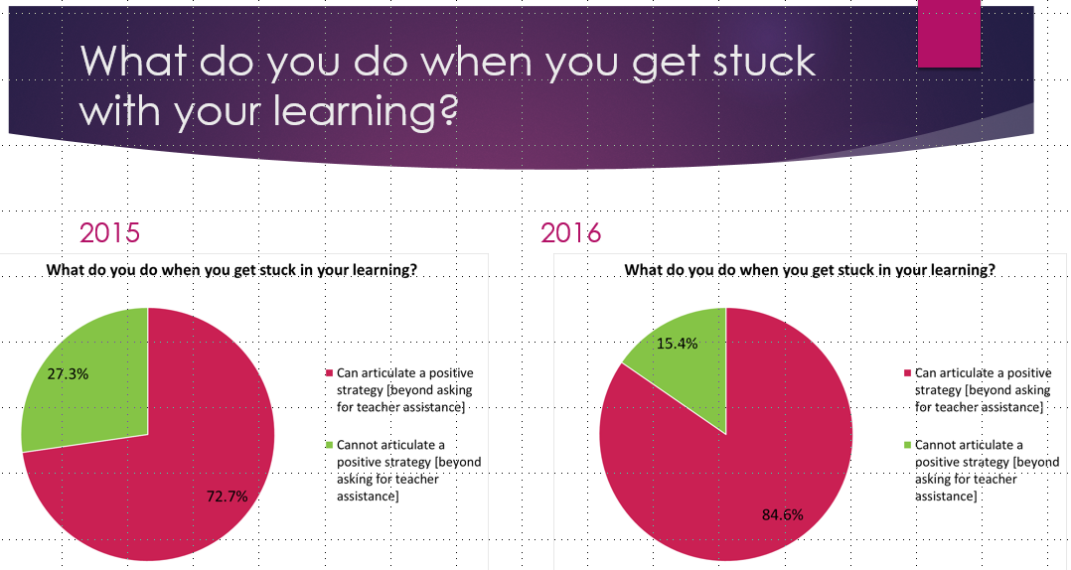
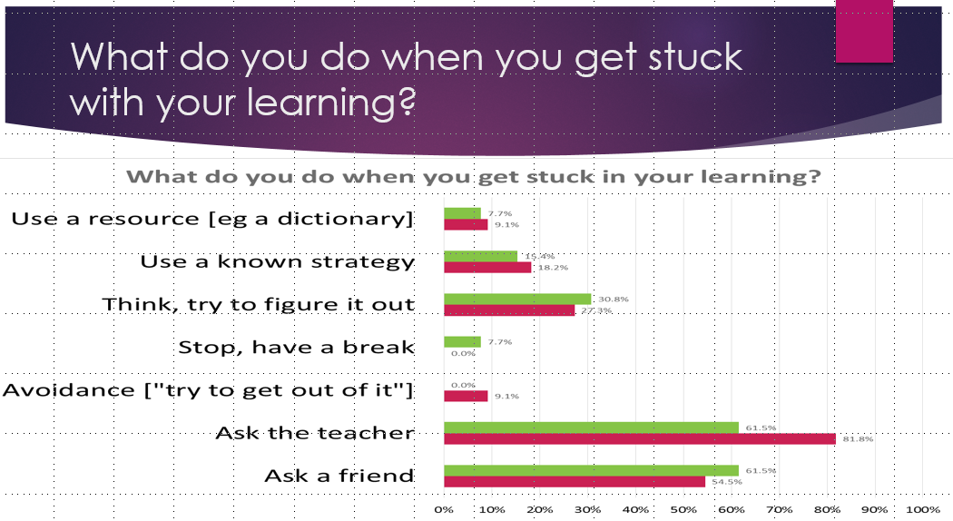
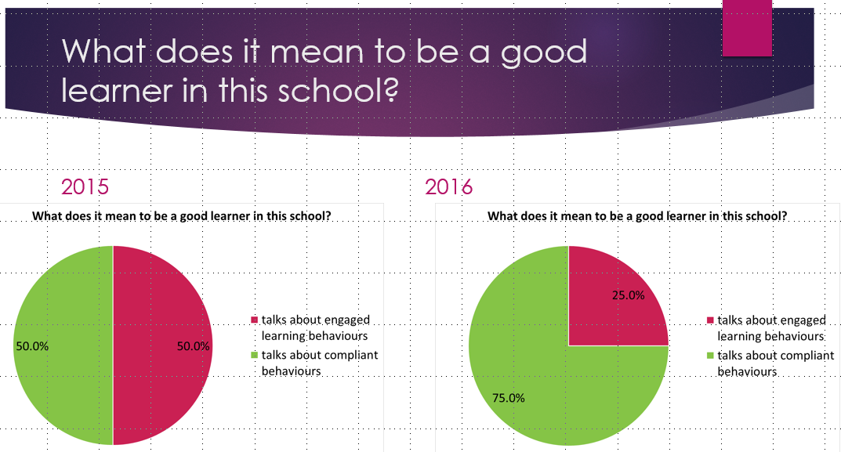

Following this recap of where we were up to with Visible Learning, we went and learned about a strategy that Shandell McAndrew and Giulia Elliott-Hall have been trialling to help their students be clear about where they are up to with their learning, what they need to learn next, etc. ‘Data Walls’ are an engaging, visual representation of student learning data that help students know about how they are learning and help motivate them to keep improving. Staff were very impressed with Shandell and Giulia’s initial efforts and teachers are now all working on trialling something similar in their own classrooms.

Still on our ‘Visible Learner’ theme, we spent a session unpacking a key strategy for being clear with students about what they are learning and what they need to do to demonstrate ‘success’ with a given task. The use of Learning Intentions and Success Criteria had already begun in an organic fashion across several classrooms, with this session focusing upon strengthening teacher understanding about how to use these effectively.
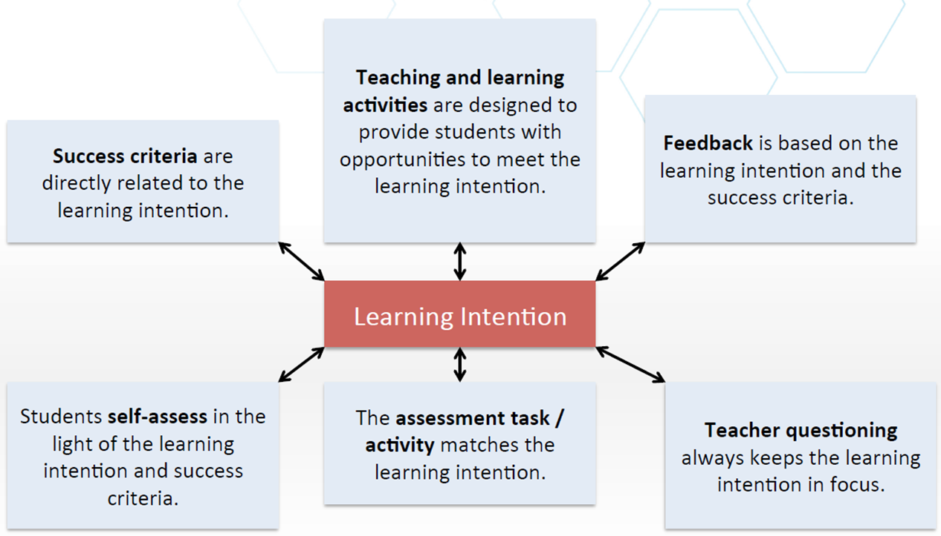
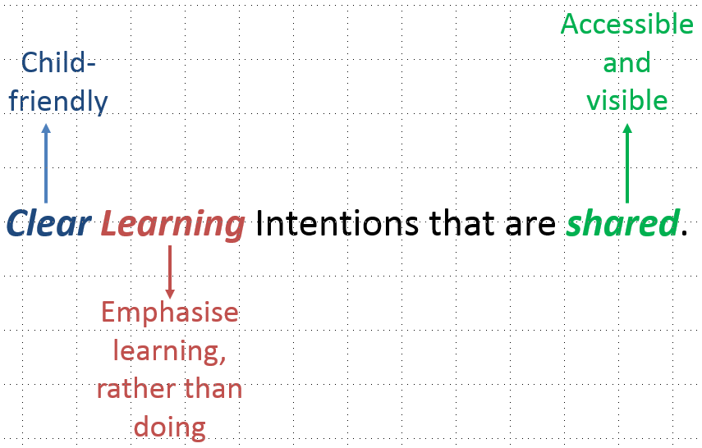
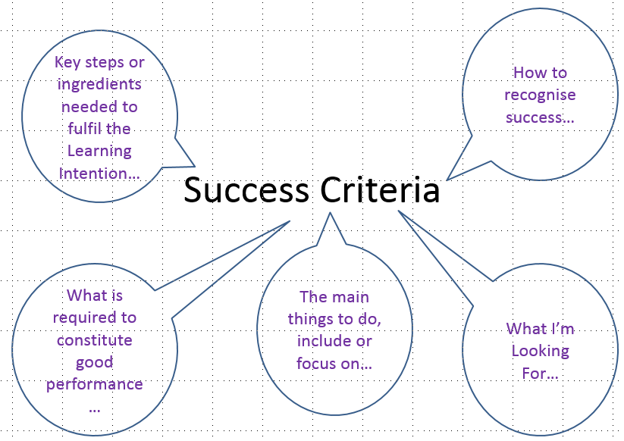

Having consolidated our first semester work on ‘The Visible Learner’, we shifted our focus to a new strand – ‘Know thy Impact’.
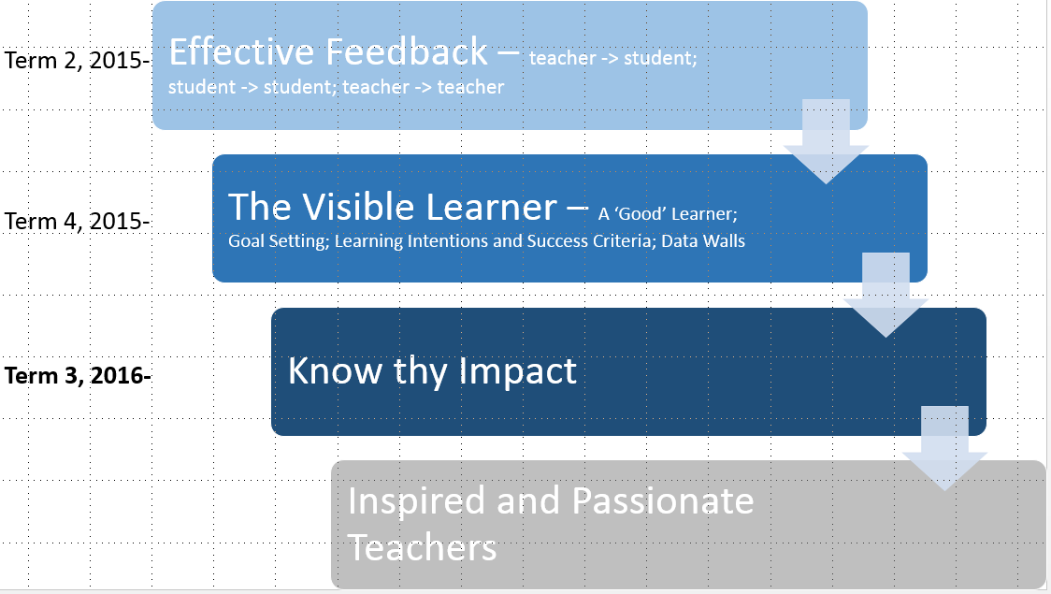

Know thy Impact is as much about teacher mindset as anything else – we need to move away from the sometimes-simplistic notion of focusing purely on achievement levels to gauge who is learning well [and subsequently who is teaching well!]. Instead, we need to focus more upon the progress [or growth] that students are making with their learning to determine who is learning well [and thus responding well to our teaching strategies, programs, etc.], as well as who is not learning so well [and thus not responding as well as they could be to our current strategies, programs, etc.]. Teachers used their most current data sets to work on identifying which students were learning well and not so well, positioning teachers to be clearer about who they needed to change some things for, as well as who was responding well to current strategies.
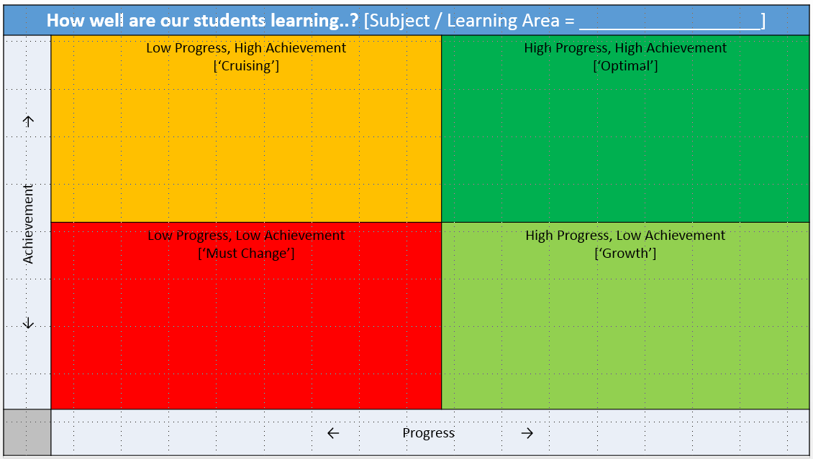
Along with Visible Learning, another of our ‘Big Five’ Improvement Priorities this year has been Growing our Enrolments and Attendance. Whilst our attendance rates have been fairly stagnant, we have certainly made some tangible growth with our enrolment levels, which currently sits on 211 – a quite significant lift from 183 at the beginning of the year. One of the most obvious impacts that changes in our enrolment figure will have is on our future budget, which is calculated based upon the ‘effective enrolment’ figure of the previous four school terms. The school’s declining numbers through 2014 and the first half of 2015 saw us funded for this year on an effective enrolment figure of 174 students. The growth that we have experienced through the second half of last year and particularly through this year is starting to be reflected in our more current effective enrolment figure, with the EE to the end of term one creeping up to 178 and at the end of term two going up a little further to 183.
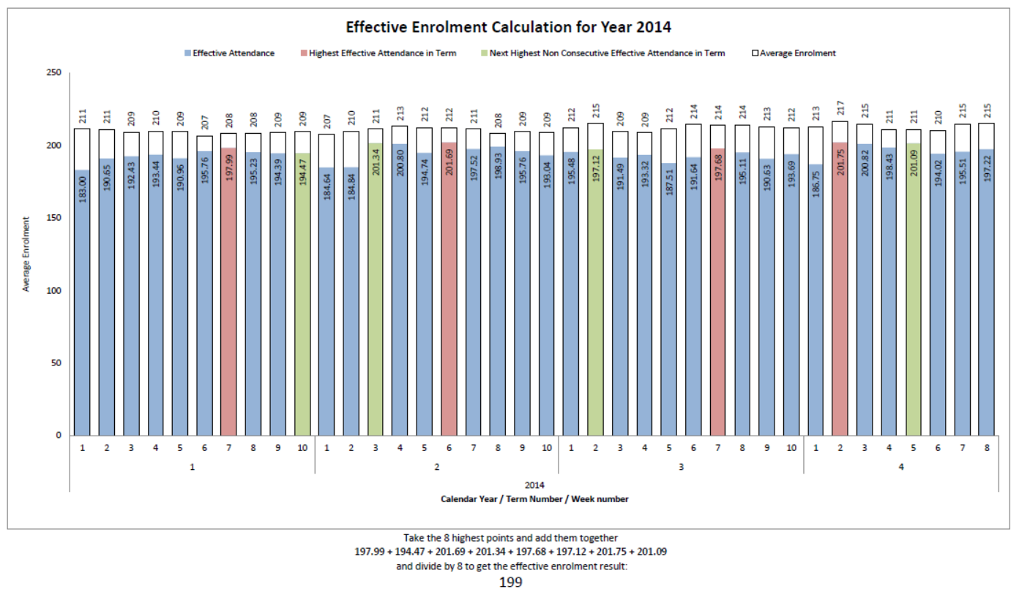
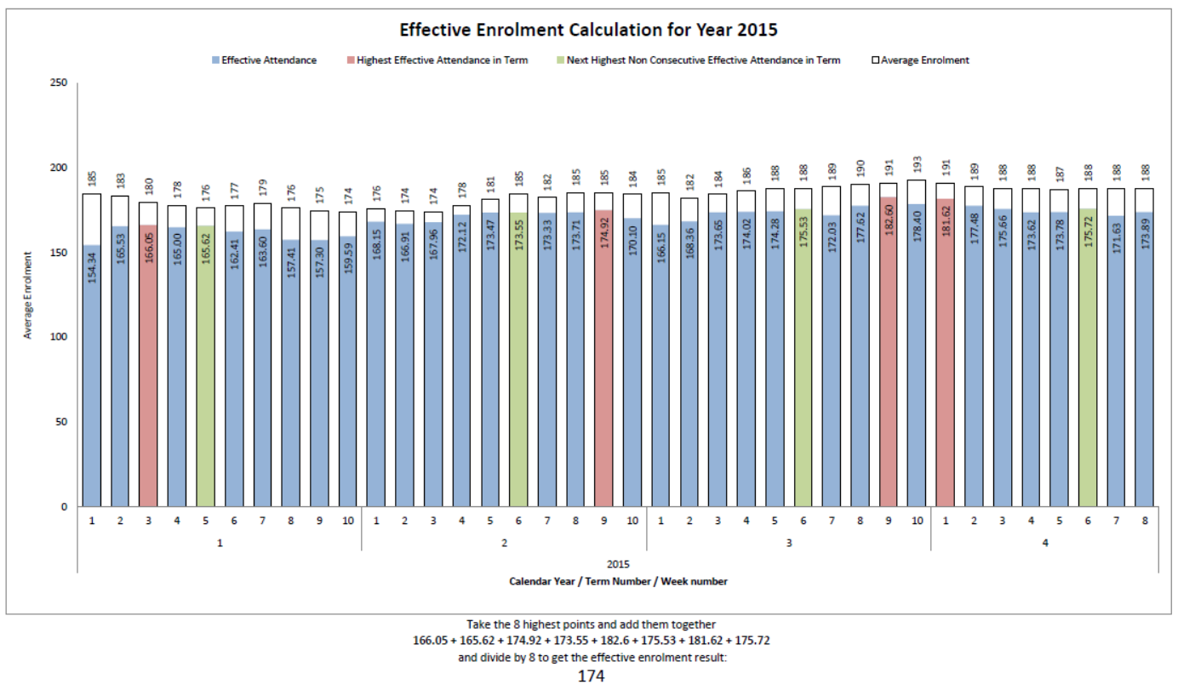
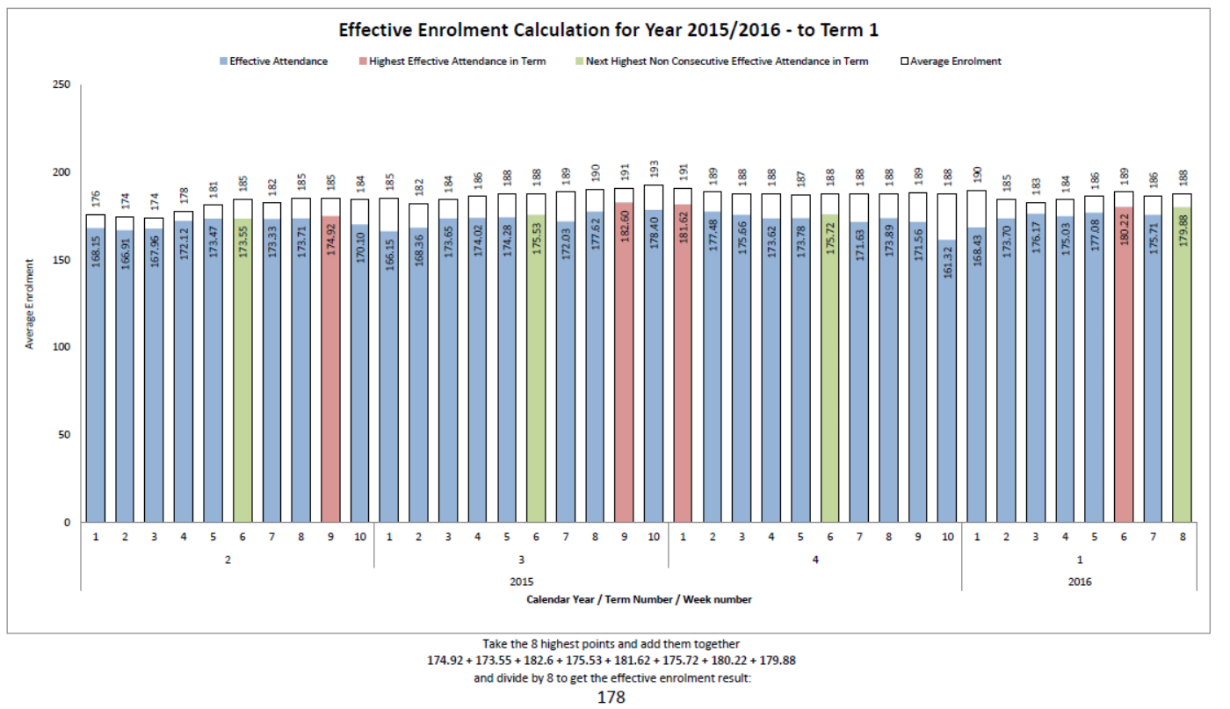
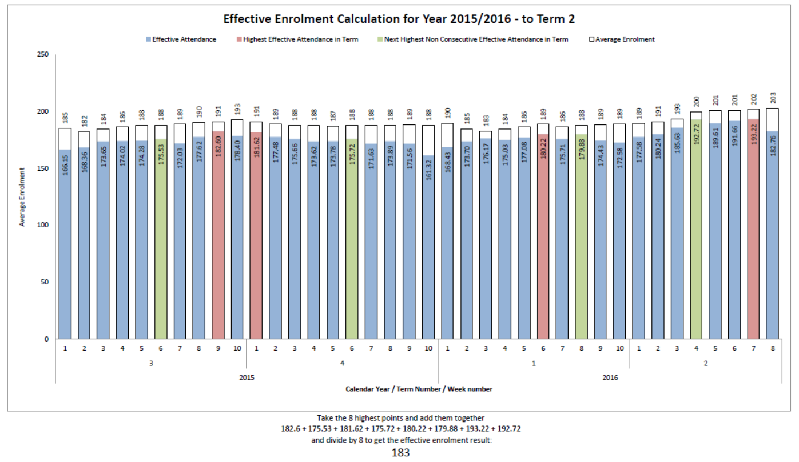

To finish, a few quick updates about events and happenings thus far in term three…
- Tina Trudgen [specialist Art teacher + 5/6 PE & English], Judy Miller [year 1/2] and Noela Heron [Preschool Assistant] have all made fantastic starts since joining Millner at the beginning of this term. All have been impressed by the positive attitude and hard work these three ladies have demonstrated already and it has been very pleasing to see both how well they have fitted into our school, but also how well they have been supported and welcomed by our existing staff.
- Several excursions and extra-curricular activities have taken place or are soon to take place, as we take advantage of a term with slightly less distractions than the other school terms, as well as the nice dry season weather.
- Millner on the Move has commenced! This is an exciting opportunity for our school to develop a ‘point of difference’ from other Darwin primary schools. Stay tuned for how this develops over the remainder of this year.
- The School Council-funded upgrading of the T/1 and Preschool spaces has largely happened, resulting in a significant ‘brightening up’ of both spaces. We are hoping that this will improve our capacity to attract parents to send their children to our preschool and primary school, further contributing to our ongoing efforts to grow our school community.

Regards,
Warwick Peter-Budge

