Millner Primary School
Sabine Road MILLNER NT 0810
“Achieving Together and Building Respect”

Principal’s Report for School Council – September, 2016

Much activity and work has occurred since our last meeting in week four of this term.
Teachers have had program meetings with me – a chance for teachers to share, discuss and receive feedback about their programs, as well as a chance for me to find out a little more detail about what, how and why teachers are teaching and students are learning. A big takeaway for me from these meetings with teachers was the obvious efforts that are being made by our team of teachers to implement some of the initiatives that we have identified as priorities or are talking about as being important for us as a school – e.g. increasing use of data and evidence to inform decisions that we make about what and how students need to learn; use of strategies arising from our Visible Learning work [Learning Intentions, Success Criteria, student goal setting, feedback, etc.]; and working collaboratively with teaching colleagues.

As usual, sport has been dominant at Millner in term three! AFL offerings have been regular this term, with the weekly after school competition against other schools, the ‘Pink Power’ tournament for girls, as well as clinics run by AFL NT.
Our participation in Jump Rope for Heart saw a whole-school focus on skipping for a few weeks, culminating in a nice whole-school ‘jump off’. Unfortunately, there was one casualty of this program, with Ms Arratta injuring her knee whilst fearlessly attempting to model some skipping technique to her students!
Recently, several classes have also participated in some tennis lessons.

Our Preschool has held two ‘Open Weeks’ this term, looking to advertise to and provide information for parents of prospective pre-schoolers. Enrolments in Preschool continue to slowly but steadily trickle in, both for this semester and for next year.

On Monday, September 5, we – along with the other schools in the ‘Nightcliff Education Network – had a pupil-free day. Having this day as a collective group of schools enabled teachers from each of the schools to get together and analyse student writing, working towards improved consistency of judgement about the relative quality of student writing. This session built upon similar activity from earlier in the year and also allowed teachers to strengthen some professional networks with colleagues in neighbouring schools, as well as share strategies regarding the teaching of writing.
Prior to the collaborative work with other schools, we had a productive morning here at Millner, where we focused upon identifying benchmarks for the various English and Maths assessments that we use through the school, positioning ourselves to be clearer about how students are achieving compared to the expected level for their year, as well as how well students are progressing compared to the expected level of progress from one year to the next.
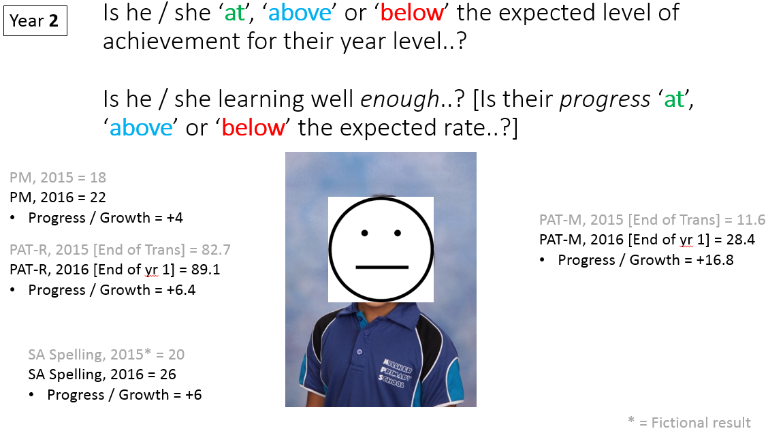
An example of the two questions that we were endeavouring to be better-placed to answer.
Student-Led Conferences happened in week seven and it was fantastic to see many parents coming into classrooms and listening to their children talk about their learning. This term, we have ramped up our focus on student goal setting, so many students took the opportunity to talk to their parents about the learning goals that they are working towards. In a nice extension of the efforts that we have been making with the use of feedback, upper primary classes used the Student-Led Conference to get some feedback from parents regarding their views about how their child’s learning is going.

Whilst on feedback from parents, we have just completed the annual school survey for the second year in a row. We had a pleasing number of responses from parents for the survey, which also sought the views of staff and our year 5/6 students. As a staff, we will be analysing the results of these surveys next week – an early step in identifying where we are ‘at’ and subsequently helping us to plan our improvement priorities for next year and beyond.
Another significant input into our planning for next year and beyond is this week’s School Review. The School Review will be conducted by Aderyn Chatterton, Regional Director, Carolyn Edwards, Principal – Henbury School, as well as Sally Winch, retired Principal – Manunda Terrace Primary School.
On planning for 2017, we have started some initial staffing planning for next year, by way of making some projections about enrolment numbers for each year level and doing some initial modelling of potential class structures. A plan has been made that details the many ‘steps along the way’ that we will work through as part of this staffing planning process, with the most significant milestone being our receipt of our preliminary budget [likely to be early next term].
Term 3 | Week 8 | Identify predicted enrolments for 2017.
 | Week 8 | Discuss potential class structures for 2017.
 | Week 10 | Confirm preferred 2017 class structure model.
 | Week 10 | Discuss and identify potential 2017 positions.  - Essential positions, e.g.*:  - Class Teachers  - NCT Teacher/s  - Preschool Assistant  - Administration Manager  - Front Office / Reception  - ‘Nice to Have’ positions, e.g.*:  - AP  - Senior Teacher/s  - Special Ed Teacher  - EAL/D  - Coaches, off-class  - Data  - Specialist subject teachers [e.g. Library, PE, Art, etc.]  - Attendance, Community Engagement, etc.  - Behaviour / Wellbeing  - Intervention and Extension  *examples only – not exhaustive and needing discussion.
Term 4 | Week 2 | Preliminary Budget, 2017.
 | Week 2 | Discuss potential 2017 staffing models.
 | Week 3 | Confirm preferred 2017 staffing model.
 | Week 3-4 | Permanent staff to identify position preferences from preferred 2017 model.
 | Week 5 | Confirm 2017 positions for permanent staff.
 | Week 5 | Identify any 2017 positions remaining as ‘vacant’ from the preferred model.
 | Week 6 | Advertise vacancies and / or extend FC staff, depending upon suitability for the position.
A timeline to keep us on track with staffing planning for 2017.

Finally, we received our NAPLAN results earlier in the term and participating students have received their individual reports. I would like to unpack our results in a little more detail at our October School Council meeting, following a session with staff on this early in term four.

Regards,
Warwick Peter-Budge

